**Title (bold, 14 point)**

*A. Authora, B. Authorb(the presenting author should be underlined)*

1X Institute, City, Country, 2University of Y, City, Country

**Title section 1:** Your abstract should conform to the following guidelines. It must fit onto a single page of A4 (29.7 cm × 21.0 cm) using margins of 2.0 cm on both sides and 2.5 cm at the top and bottom. All abstracts should be submitted in PDF format. The main body of the abstract should use 12 point and the font should be Times New Roman. Please use single spacing. References [1] should follow the format below and use 10 point.

**Title section 2:** The following sections should be included in the abstract:

* 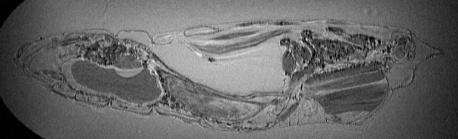Introduction
* Methods
* Results and discussion
* Conclusion
* References

Fig. 1: Figure caption should use 10-point text and placed underneath the figure with a similar width as the figure, or on the right side of the figure.

**Title section 3:** Figures can be included in the abstract, such as the example shown, with a maximum of 3 figures per abstract. Equations can also be included and should be numbered as follows:

$ϕ=γ\int{G_{\text{x}}\left(t\right) x \text{d}t}=k_{\text{x}} x$ Eq. 1

**References:** [1] Torrey, Phys. Rev. (1956). [2] Brownstein, Phys. Rev. (1979).